***AIDS MICROPROCESSOR LAB S21 BATCH (2023-24)***

***Experiment 3(a) Title: Assembly language programming to find minimum number from 10 8-bit hexadecimal numbers (GIVEN ARRAY) using software tool TASM 1.4***

***Name of student: Meet Raut Class Roll Number: 2201084***

***Date of Performance: 26/02/2024***

***Batch: S2-1 Timing: 3:00-5:00 Date of Submission: 26/02/2024***

***Assembly language code***

*data segment # Data segment*

*array db 04h,02h,03h,0Ch,05h, # Declares an array named array with ten*

*07h,08h,0Ah,0Bh,01h 8-bit hexadecimal numbers.*

*smaller db 00h # Declares a variable smaller with an initial value of 00h.*

*data ends # Assemble directives*

*code segment*

*assume cs:code, ds:data # Assemble directives defining cs and ds*

*start: # start of code segment*

*mov ax,data # moving data to ax register- initialization process*

*mov ds,ax # moving ax to dx register -- initialization process*

*mov si,offset array # Uses si register to point to beginning of the array.*

*mov cl,0Ah #Initializes a counter (cx) with the value 0Ah*

*mov al,[si] # moves the value at the array location to al.*

*inc si # Increments the si register*

*back: cmp al,[si] # Enters a loop (back) that compares the value in al with . the value at the memory location pointed to by si*

*jnc skip # If the value in al is not less than the value in the array . . (jnc skip), it skips to the label skip*

*skip: mov al,[si] # moves the value at the array location to al.*

*inc si # Increments the si register*

*loop back # repeats the loop until cx becomes zero.*

*mov smaller,al # Stores the final value in al into the smaller variable.*

*int 03h # breakpoint interrupt*

*code ends # Assembler directives to end code*

*end start # Assembler directives to end start*

*Result:*

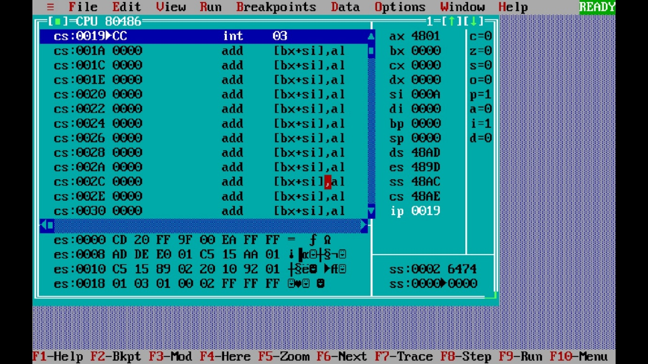

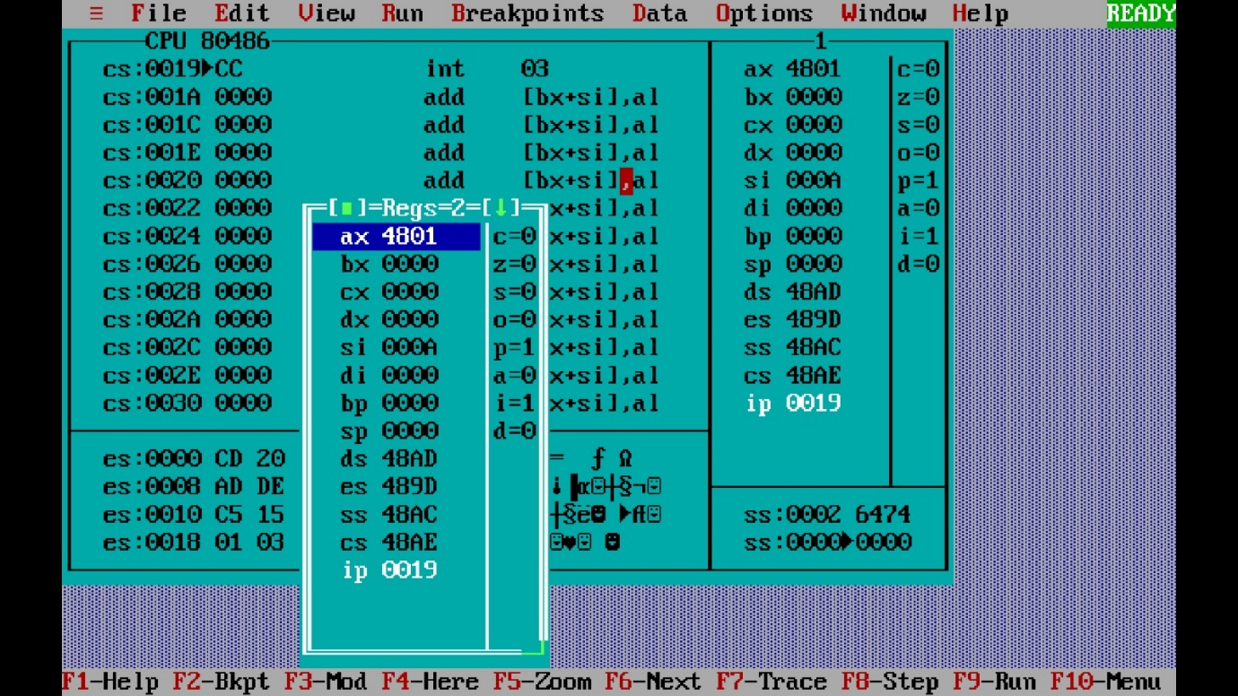

***Experiment 3(b) Title: Assembly language programming to find maximum number from 10 8-bit hexadecimal numbers (GIVEN ARRAY) using software tool TASM 1.4***

***Name of student: Meet Raut Class Roll Number: 2201084***

***Date of Performance: 26/02/2024***

***Batch: S2-1 Timing: 3:00-5:00 Date of Submission: 26/02/2024***

***Assembly language code***

*data segment # Data segment*

*array db 01h,02h,03h,04h,05h, #* *Declares an array named array with ten*

*07h,08h,0Ah,0Bh,0Ch 8-bit hexadecimal numbers.*

*larger db 00h #* *Declares a variable larger with an initial value of 00h.*

*data ends # Assemble directives*

*code segment*

*assume cs:code, ds:data # Assemble directives defining cs and ds*

*start: # start of code segment*

*mov ax,data # moving data to ax register- initialization process*

*mov ds,ax # moving ax to dx register -- initialization process*

*mov cx,0Ah #Initializes a counter (cx) with the value 0Ah*

*mov si,offset array # Uses si register to point to beginning of the array.*

*mov al,00h # Initializes the al register with the value 00h.*

*back: cmp al,[si] #* *Enters a loop (back) that compares the value in al with . the value at the memory location pointed to by si*

*jnc skip #* *If the value in al is not less than the value in the array . . (jnc skip), it skips to the label skip*

*mov al,[si] # moves the value at the array location to al.*

*skip: inc si #* *Increments the si register*

*loop back # repeats the loop until cx becomes zero.*

*mov larger,al #* *Stores the final value in al into the larger variable.*

*int 03h # breakpoint interrupt*

*code ends # Assembler directives to end code*

*end start # Assembler directives to end start*

*Result:*

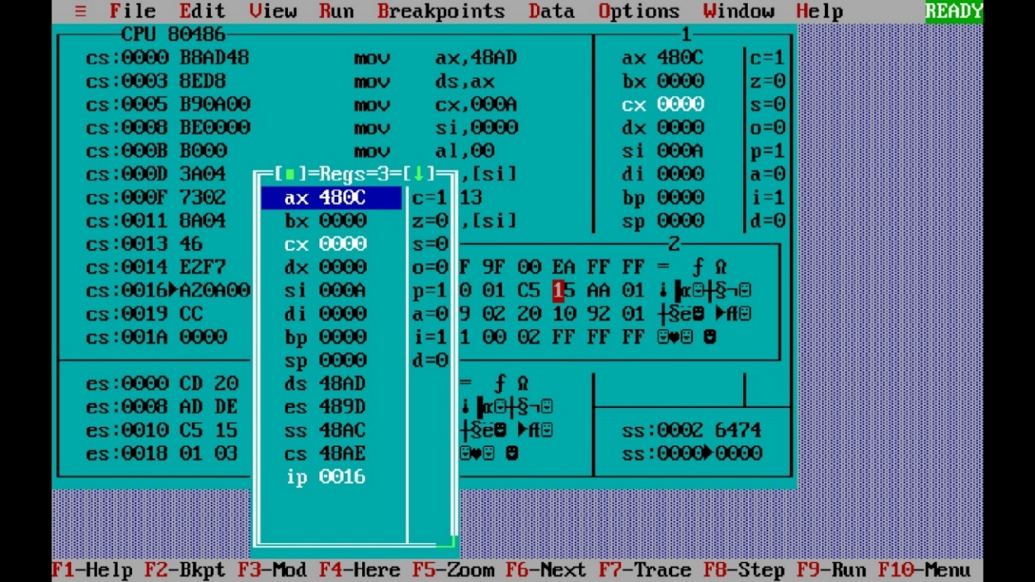

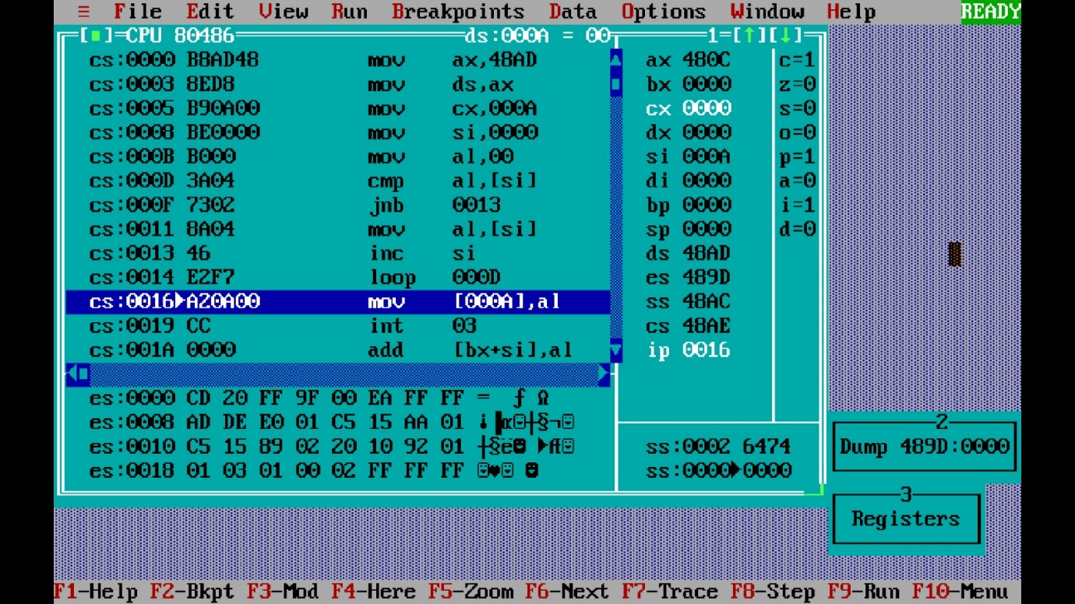

***CONCLUSION: LO 2, LO 3 mapped.***

***---------------------------------*****************************-----------------------------------***